Joseph and Arthur Pugh (written by Graham Blackmore)

Joseph Pugh was born 30/4/1876 in Station Cottage, Station Road, Rhostyllen to William & Catherine Pugh (Kate).
Joined the RWF at the start of the war and was killed in action on the Somme on 11/11/1916 aged 41. He was a private 1st class number 5367.
He is buried at Grove Town Cemetery Meaulte, Somme.
His brother was Arthur Taylor Pugh born 5/6/1886 also at Station Cottage he also joined the RWF at the start of the conflict and was killed in action in Mesopotamia 16/5/1916 aged 30. He was also a private number 11647 and is buried at Amara War Cemetery in Iraq not far from Basra.
These two men were my grandmother Margaret’s brothers, who also lived in Rhostyllen until her death in 1980, she lived with her husband Tom Evans and children Marjorie & Arthur at 62 Langdale Avenue. Marjorie being my mother.
The funny thing is I now live in Station Road although the cottage has long gone. Small world!!

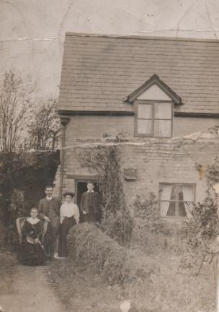

Station Cottage, Station Road, Rhostyllen.

